Numerical damping of oscillations of beams by using multiple point actuators
A.G. Atamuratov¹ , I.E. Mikhailov² , N.A. Taran³
¹ ”PPK” Ltd, Moscow, Russia, gooffydog@mail.ru
² FRC IC RAS, , Moscow, Russia, mikh_igor@mail.ru
³ Moscow Aviation Institute (National Research University), n1ckolaytaran@gmail.com

Forced transverse oscillations of an elastic beam are described by the equation:

The initial conditions: deviation and velocity - are known:

On the boundary of a beam imposes fixing conditions: y(t, 0) = y(t, l) = y_{xx}(t, 0) = y_{xx}(t, l) = 0.
The problem of damping is: to find the control function g(t, x), which allows to get the state of a beam from initial state (1) to final state for the minimum time T: y(T, x) = 0, y_{t}(T, x) = 0.
In [1], to solve this problem, there was considered usage of functions specified in the form g(t, x) = W(t)f(x), simulating point actuators, where f(x) is a known function, and W(t) - control function. However, in the case of a static point actuator, the solution of the problem may not exist if actuator is placed in the node of standing waves (Fig. 1).
In this report we consider the damping of oscillations of a beam by using multiple point actuators. The function g(t, x) is considered in the form: .

where x_{i} - the points on a beam where actuators are placed, δ(x - x_{i}) is Dirac delta function and W_{i}(t) are control functions. To find the required control functions we use the second order Marquardt minimization method for finding the unconditional minimum of the corresponding functional.
E x a m p l e. Let us consider a damping of oscillations of a beam with l = 1, a = 1 by using one and two point actuators, which are placed at x₁ = 0.5 and x₁ = 0.25, x₂ = 0.75 respectively. The initial conditions (1) are h₀ = 0.25sin(πx/l), h₁(x) = 0, ε = 10⁻⁴. Figures 1 and 2 show process of damping oscillations of y(t, x).
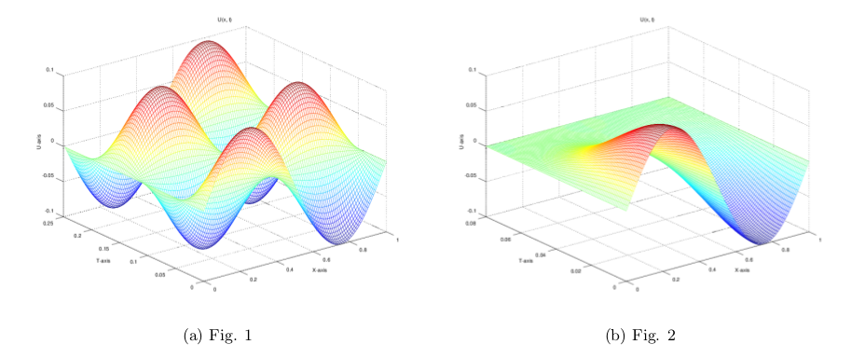
In Fig. 1, 2, respectively, solutions obtained with the single actuator placed at point x₀ = l/2 (undamped oscillations), and using two actuators (the problem was solved by time T = 0.08).
This work was supported by a grant of Russian Science Foundation 17-19-01247.

REFERENCES
1. A.G. Atamuratov, I.E. Mikhailov, L.A. Muravey. The Moment Problem and Vibrations Damping of
Beams and Plates // AIP Conf. Proc. V. 1738, 2016, 480024-1480024-5.

